1. Let’s create in-memory users (more than one now).
2. The main disadvantage of Basic-Auth is that every time we make request, we have to pass username and password.
3. Agenda:
   1. We will create multiple users and store them in in-memory object provided by Spring Security.
   2. We will assign a role to each user.
   3. We will try to access RESTful APIs based on roles.
4. 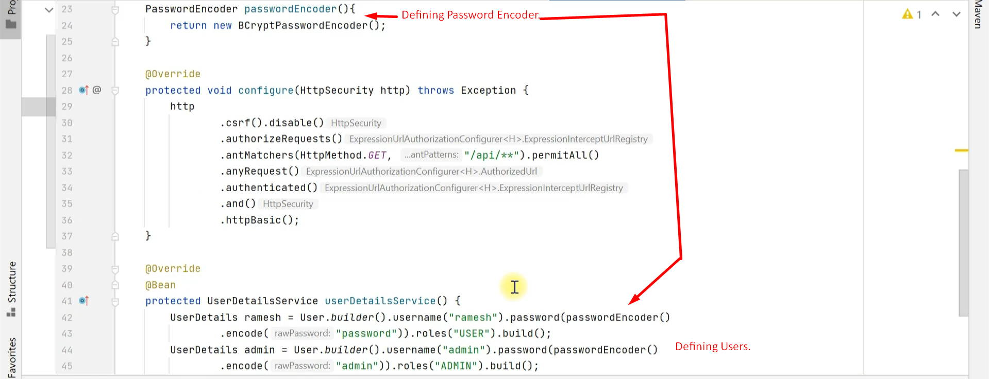  
   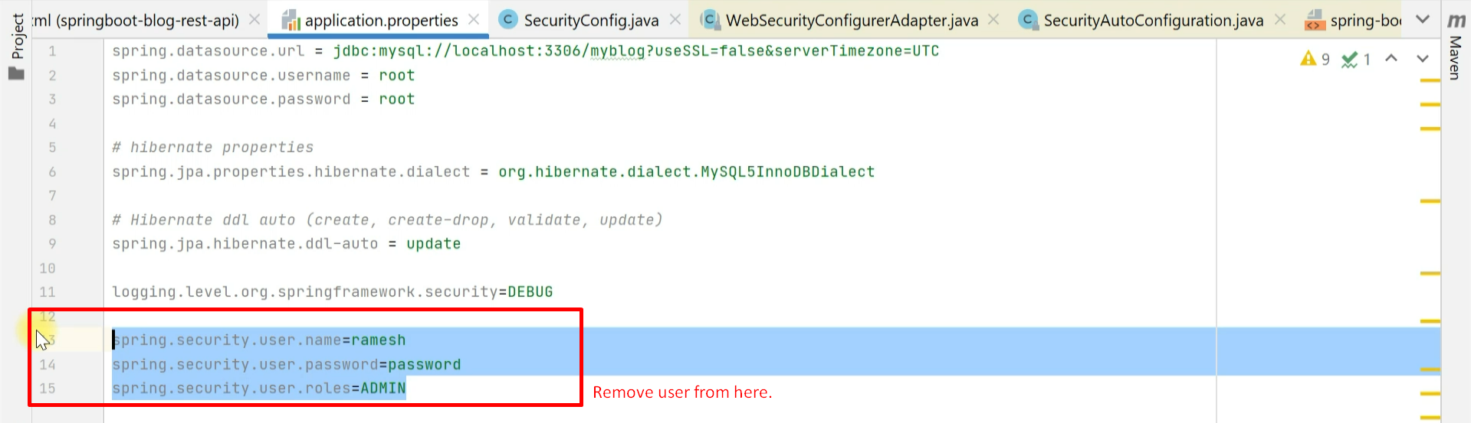
5. 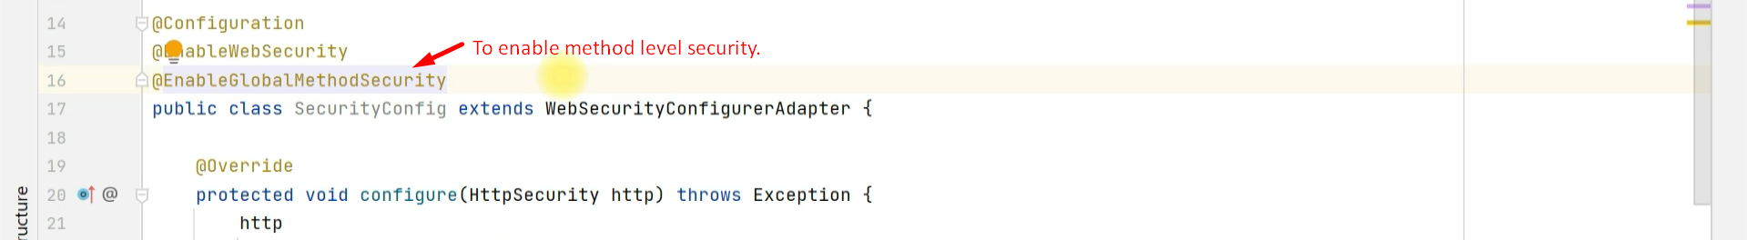
6. 
7. 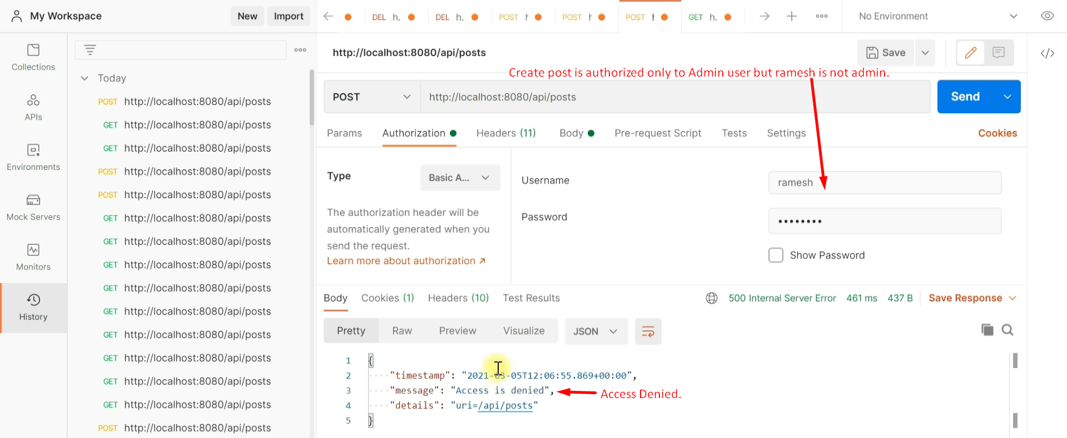
8. So actually, we provided role-based authentication.